Python Assignment 5

1. Write a Python program to find those numbers which are divisible by 7 and multiple of 5, between 1500 and 2700 (both included)

numbers = []

ANS:

for num in range(1500, 2701)

if num % 7 == 0 and num % 5 == 0: numbers.append(num)

print("Numbers divisible by 7 and multiple of 5 between 1500 and 2700:") print(numbers)

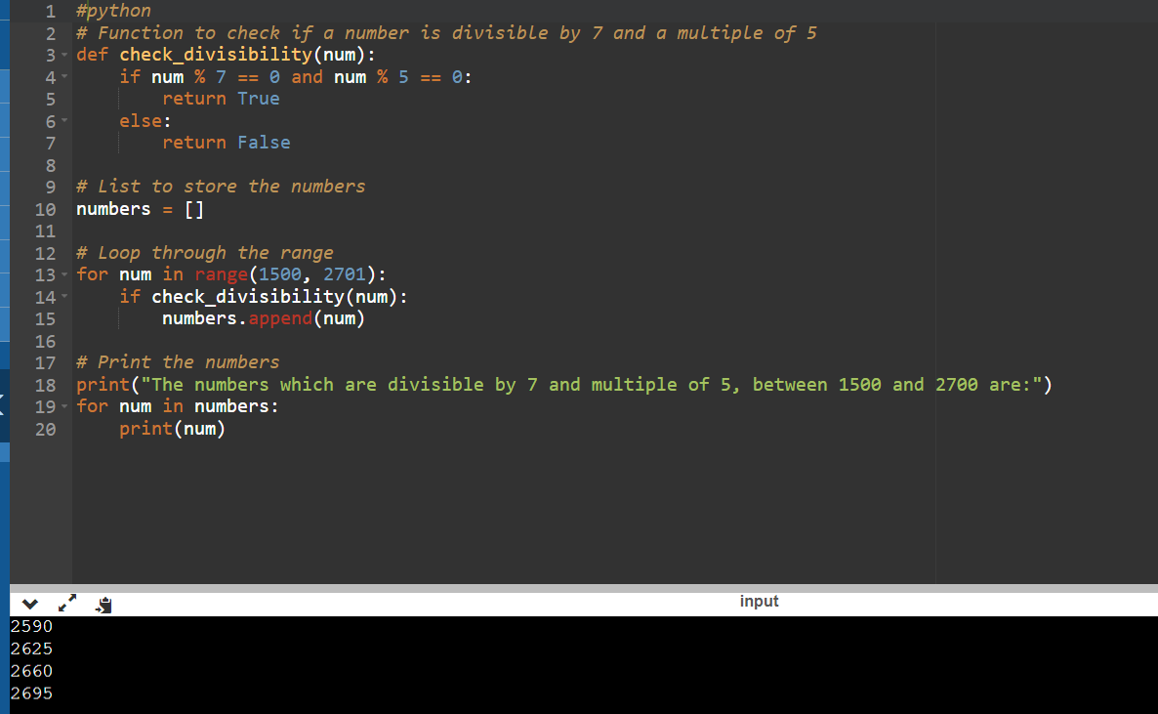

1. Write a Python program that prints all the numbers from 0 to 6 except 3 and 6. Note : Use 'continue' statement.

Expected Output : 0 1 2 4 5

ANS:

for num in range(7):

if num == 3 or num == 6: continue

print(num, end=" ") print()

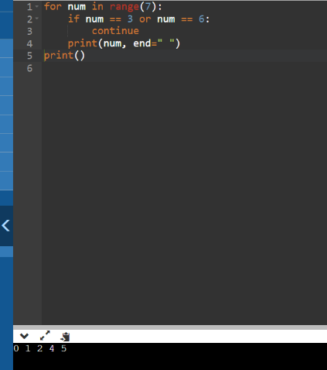

1. Write a Python program which iterates the integers from 1 to 50. For multiples of three print "Fizz" instead of the number and for the multiples of five print "Buzz". For numbers which are multiples of both three and five print "FizzBuzz". *Sample Output* :

fizzbuzz 1

2

fizz 4

Buzz ANS:

for num in range(1, 51):

if num % 3 == 0 and num % 5 == 0: print("FizzBuzz")

elif num % 3 == 0: print("Fizz")

elif num % 5 == 0: print("Buzz")

else:

print(num)

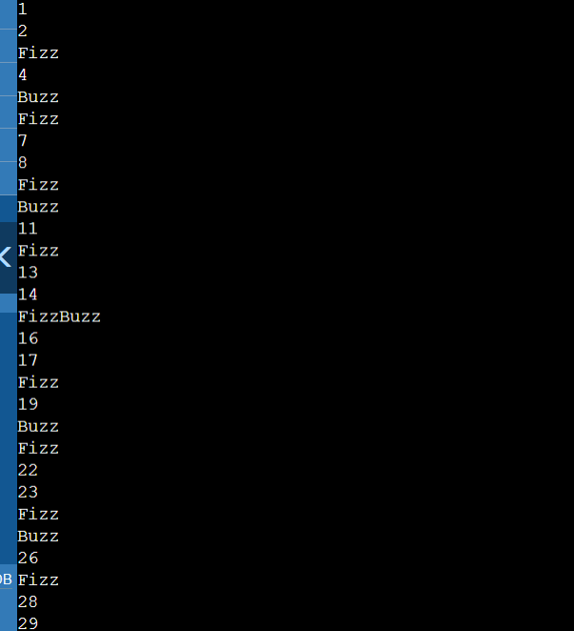

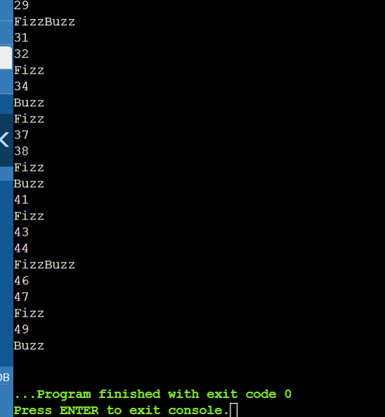

1. Write a Python program to check a triangle is equilateral, isosceles or scalene. Note :

An equilateral triangle is a triangle in which all three sides are equal. A scalene triangle is a triangle that has three unequal sides.

An isosceles triangle is a triangle with two equal sides.

*Expected Output:*

Input lengths of the triangle sides:

x: 6

y: 8

z: 12

Scalene triangle

ANS:

x = float(input("Input length of the first side (x): "))

y = float(input("Input length of the second side (y): ")) z = float(input("Input length of the third side (z): "))

if x == y == z: print("Equilateral triangle")

elif x != y != z != x: print("Scalene triangle")

else:

print("Isosceles triangle")

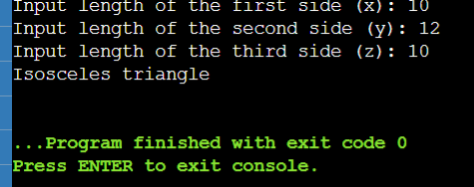

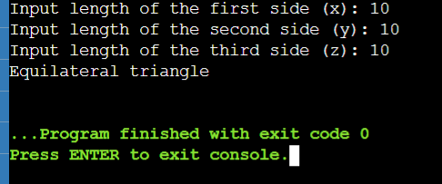

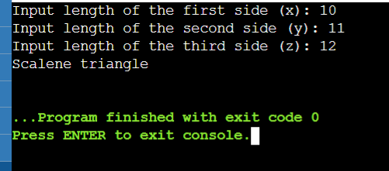

1. Write a Python program to calculate the sum and average of n integer numbers (input from the user). Input 0 to finish

ANS:

sum = 0

count = 0 while True:

num = int(input("Enter an integer number (enter 0 to finish): ")) if num == 0:

break sum += num count += 1

average = sum / count if count > 0 else 0 print("Sum:", sum)

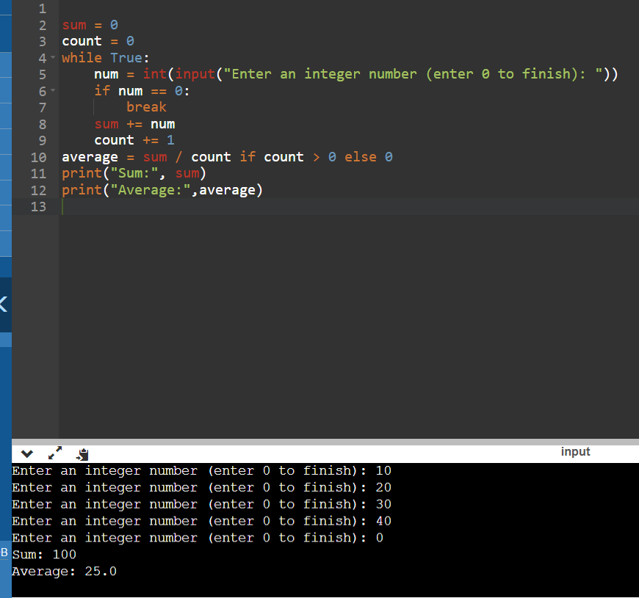print("Average:", average)

1. Write a Python program to construct the following pattern, using a nested loop number.

1

22

333

4444

55555

666666

7777777

88888888

999999999

ANS:

for i in range(1, 10): for j in range(i):

print(i, end="") print()

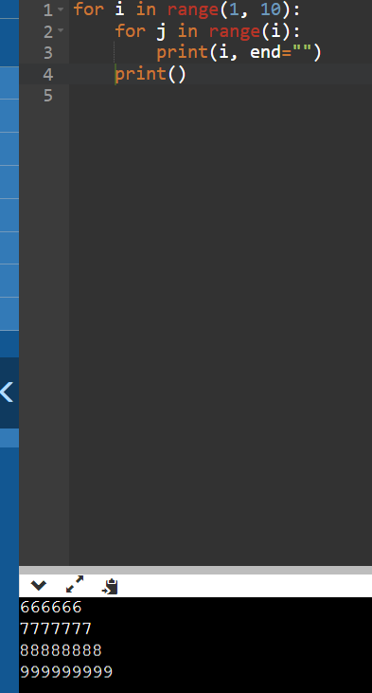

1. Write a Python program that counts the number of elements within a list that are greater than 30.

ANS:

my_list = [15, 27, 35, 48, 22, 39, 40, 10, 50]

count = 0

for num in my_list: if num > 30:

count += 1

print("Number of elements greater than 30:", count)

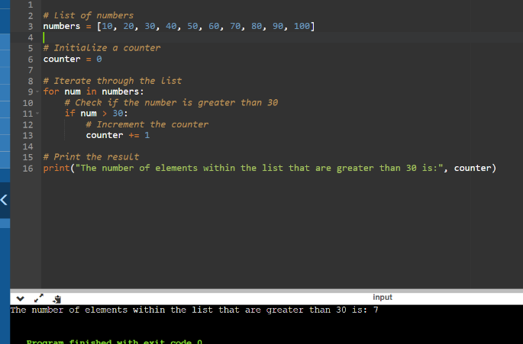

# Take values of length and breadth of a rectangle from user and check if it is square or not.

ANS:

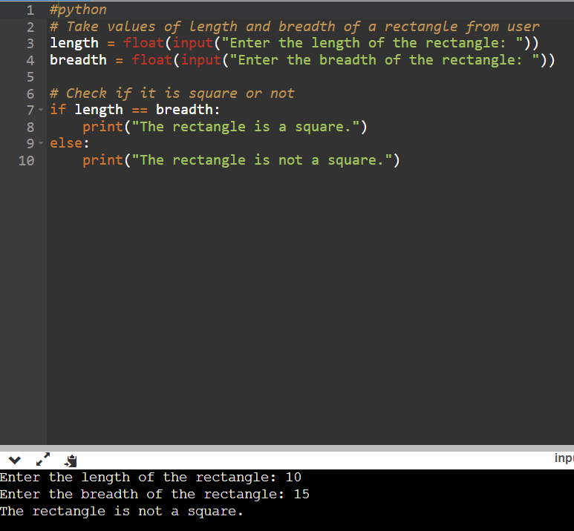

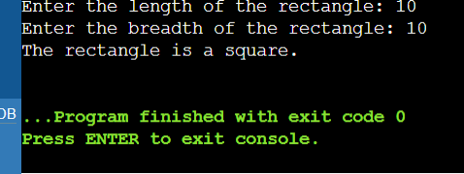

# A shop will give discount of 10% if the cost of purchased quantity is more than 1000.

Ask user for quantity

# Suppose, one unit will cost 100. Judge and print total cost for user.

ANS:

# Take values of quantity and unit cost from user

quantity = float(input("Enter the quantity of items: "))

unit_cost = float(input("Enter the cost per unit: "))

# Calculate the total cost

total_cost = quantity * unit_cost

# Check if the total cost is more than 1000

if total_cost > 1000:

# Calculate the discount

discount = total_cost * 0.10

# Calculate the total cost after discount

total_cost_after_discount = total_cost - discount

# Print the total cost after discount

print("The total cost for the user after the discount is:", total_cost_after_discount)

else:

# Print the total cost

print("The total cost for the user is:", total_cost)

1. A company decided to give bonus of 5% to employee if his/her year of service is more than 5 years.

Ask user for their salary and year of service and print the net bonus amount.

ANS:

# Take values of salary and year of service from user

salary = float(input("Enter your salary: "))

year_of_service = float(input("Enter your year of service: "))

# Check if the year of service is more than 5 years

if year_of_service > 5:

# Calculate the bonus of 5%

bonus = salary * 0.05

# Print the net bonus amount

print("The net bonus amount for the employee is:", bonus)

else:

# Print that the employee is not eligible for a bonus

print("The employee is not eligible for a bonus.")

1. A school has following rules for grading system:
2. Below 25 - F
3. 25 to 45 - E
4. 45 to 50 - D
5. 50 to 60 - C
6. 60 to 80 - B
7. Above 80 - A

Ask user to enter marks and print the corresponding grade. ANS:

# Take value of marks from user

marks = float(input("Enter your marks: "))

# Check the range of marks and assign the corresponding grade

if marks < 25:

grade = 'F'

elif 25 <= marks < 45:

grade = 'E'

elif 45 <= marks < 50:

grade = 'D'

elif 50 <= marks < 60:

grade = 'C'

elif 60 <= marks < 80:

grade = 'B'

else:

grade = 'A'

# Print the corresponding grade

print("The corresponding grade for the entered marks is:", grade)

1. A student will not be allowed to sit in exam if his/her attendence is less than 75%.

Take following input from user Number of classes held Number of classes attended.

And print

percentage of class attended

Is student is allowed to sit in exam or not.

ANS:

python

# Take input from user

number_of_classes_held = int(input("Enter the number of classes held: "))

number_of_classes_attended = int(input("Enter the number of classes attended: "))

# Calculate percentage of class attended

percentage_of_class_attended = (number_of_classes_attended / number_of_classes_held) * 100

# Check if student is allowed to sit in exam

if percentage_of_class_attended >= 75:

is_allowed_to_sit_in_exam = "Yes"

else:

is_allowed_to_sit_in_exam = "No"

# Print results

print("Percentage of class attended:", percentage_of_class_attended)

print("Is the student allowed to sit in the exam?", is_allowed_to_sit_in_exam)

1. Take 10 integers from keyboard using loop and print their average value on the screen.

ANS:

# Initialize a variable to store the sum of the numbers

total = 0

# Use a loop to take 10 integers from the keyboard

for i in range(10):

# Take an integer from the keyboard and add it to the total

num = int(input("Enter an integer: "))

total += num

# Calculate the average of the numbers

average = total / 10

# Print the average of the numbers

print("The average of the numbers is:", average)

1. Print multiplication table of 24, 50 and 29 using loop. ANS:

# Define the list of numbers for which we want to print the multiplication table

numbers = [24, 50, 29]

# Iterate over each number in the list

for num in numbers:

print(f"\nMultiplication Table of {num}:")

# Iterate over the range from 1 to 11 (inclusive)

for i in range(1, 11):

# Calculate the product of the current number and the current index

product = num * i

# Print the product

print(f"{num} x {i} = {product}")

1. Take integer inputs from user until he/she presses q ( Ask to press q to quit after every integer input ). Print average and product of all numbers.

ANS:

python

def calculate_average_and_product(numbers):

product = 1

for num in numbers:

product *= num

average = sum(numbers) / len(numbers)

return average, product

def main():

numbers = []

while True:

num = input("Enter an integer (or press 'q' to quit): ")

if num == 'q':

break

numbers.append(int(num))

if numbers:

average, product = calculate_average_and_product(numbers)

print(f"\nAverage of all numbers: {average}")

print(f"Product of all numbers: {product}")

else:

print("\nNo numbers entered.")

if __name__ == "__main__":

main()

1. Take inputs from user to make a list. Again take one input from user and search it in the list and delete that element, if found. Iterate over list using for loop.

def main():

# Take inputs from user to make a list

numbers = []

while True:

num = input("Enter an integer (or press 'q' to quit): ")

if num == 'q':

break

numbers.append(int(num))

# Take one input from user and search it in the list

num_to_delete = int(input("Enter an integer to delete from the list: "))

# Search for the element in the list and delete it, if found

if num_to_delete in numbers:

numbers.remove(num_to_delete)

print(f"{num_to_delete} has been removed from the list.")

else:

print(f"{num_to_delete} is not in the list.")

# Iterate over the list using a for loop

print("The remaining elements in the list are:")

for num in numbers:

print(num)

if __name__ == "__main__":

main()

1. Using range(1,101**)**, make three list,
   1. one containing all even numbers
   2. one containing all odd numbers
   3. One containing only prime numbers.

def is_prime(n):

if n <= 1:

return False

if n <= 3:

return True

if n % 2 == 0 or n % 3 == 0:

return False

i = 5

while i * i <= n:

if n % i == 0 or n % (i + 2) == 0:

return False

i += 6

return True

even_numbers = []

odd_numbers = []

prime_numbers = []

for i in range(1, 101):

if i % 2 == 0:

even_numbers.append(i)

else:

odd_numbers.append(i)

if is_prime(i):

prime_numbers.append(i)

print("Even numbers: ", even_numbers)

print("Odd numbers: ", odd_numbers)

print("Prime numbers: ", prime_numbers)

1. From the two list obtained in previous question, make new lists, containing only numbers which are divisible by 4, 6, 8, 10, 3, 5, 7 and 9 in separate lists.

def is_prime(n):

if n <= 1:

return False

if n <= 3:

return True

if n % 2 == 0 or n % 3 == 0:

return False

i = 5

while i * i <= n:

if n % i == 0 or n % (i + 2) == 0:

return False

i += 6

return True

even_numbers = []

odd_numbers = []

prime_numbers = []

for i in range(1, 101):

if i % 2 == 0:

even_numbers.append(i)

else:

odd_numbers.append(i)

if is_prime(i):

prime_numbers.append(i)

divisible_by_4 = [num for num in even_numbers if num % 4 == 0]

divisible_by_6 = [num for num in even_numbers if num % 6 == 0]

divisible_by_8 = [num for num in even_numbers if num % 8 == 0]

divisible_by_10 = [num for num in even_numbers if num % 10 == 0]

divisible_by_3 = [num for num in odd_numbers if num % 3 == 0]

divisible_by_5 = [num for num in odd_numbers if num % 5 == 0]

divisible_by_7 = [num for num in odd_numbers if num % 7 == 0]

divisible_by_9 = [num for num in odd_numbers if num % 9 == 0]

print("Divisible by 4: ", divisible_by_4)

print("Divisible by 6: ", divisible_by_6)

print("Divisible by 8: ", divisible_by_8)

print("Divisible by 10: ", divisible_by_10)

print("Divisible by 3: ", divisible_by_3)

print("Divisible by 5: ",

1. From a list containing ints, strings and floats, make three lists to store them separately

def separate_elements(input_list):

int_list = []

float_list = []

string_list = []

for element in input_list:

if isinstance(element, int):

int_list.append(element)

elif isinstance(element, float):

float_list.append(element)

elif isinstance(element, str):

string_list.append(element)

return int_list, float_list, string_list

input_list = [1, 2.0, "hello", 3, 4.5, "world"]

int_list, float_list, string_list = separate_elements(input_list)

print("Int List: ", int_list)

print("Float List: ", float_list)

print("String List: ", string_list)

1. You are given with a list of integer elements. Make a new list which will store square of elements of previous list.

ANS: def square_elements(input_list):

return [element ** 2 for element in input_list]

input_list = [1, 2, 3, 4, 5]

squared_list = square_elements(input_list)

print("Squared List: ", squared_list)